Standard Operating Procedure
Hydra Operation



ODISHA MINING CORPORATION LTD.
KODINGAMALI BAUXITE MINE

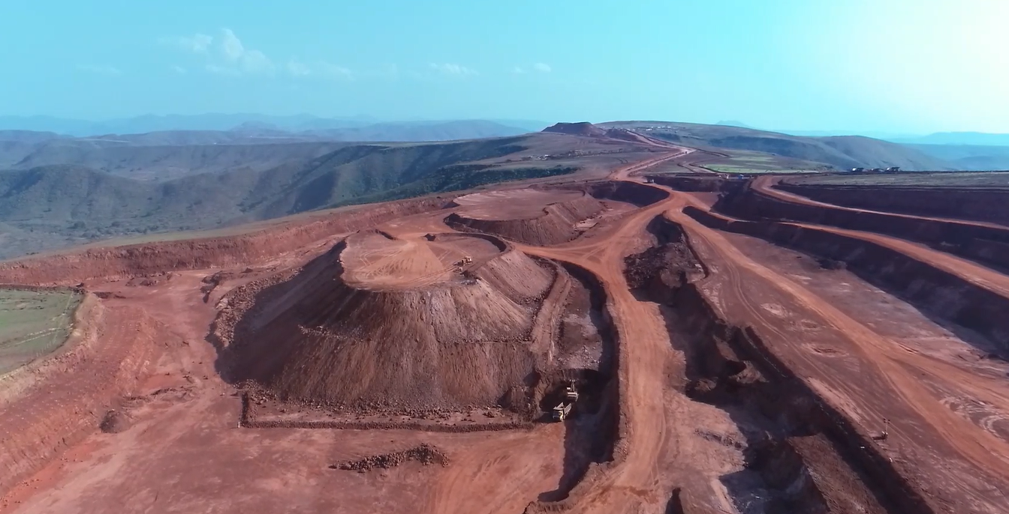

Authorized By

- PURPOSE:

To provide the standard operating procedure for Mobile Crane (Hydra) in Kodingamali Bauxite Mine.

- SCOPE:

This procedure is applicable for safe Operation of Mobile Crane (Hydra) in Kodingamali Bauxite Mine.

- RESPONSIBILITY:

 | Mobile Crane Operation | Hydra Operator
 | Mobile Crane Maintenance | Maintenance vehicle Incharge
 | Field Operation | Supervisor/Shift Incharge
 | Operational Control | Area in-charge

- SAFETY AND HEALTH HAZARDS:

- Slip/trip/fall.
- Head on Collision.
- Roll Over/Toppling of hydra.
- Hitting to other Truck/Structure/Persons.
- Dust generation during Operation.
- Noise during Operation.
- Vibration during Operation.
- Diesel/ Hydraulic Oil - Inflammable, Fire hazards.
- Acid Batteries- Skin contact can lead to extensive and severe burns and highly toxic.

In order to avoid injuries to personal and damage to machinery, the following precautions are very important.
- Work required PPE i.e. with safety shoes, helmet, dust musk, fluorescent jacket suitable for long distance visibility etc.
- Adherence to Traffic Rules guidelines framed by Mines Manager.
- Pre Operation Safety features checklist.
- Regular Checks & Maintenance.

Note: Report immediately to Supervisor, Shift Incharge and Safety officer for any incident/accident.

- ENVIRONMENT ASPECT:

- Dust generation
- Noise Pollution
- Vibration
- Oil Spillage

Preventive measures:

- Driver shall have heavy vehicle driving license.
- Load testing. Registration Paper. Load chart.
- Capacity of the Pick & Carry Crane marked on Pick & Carry Crane.
- PUC Certificate. SWL Display. Vehicle fitness certificate from RTO.

- TOOLS:

All Work required PPEs like Safety Helmet, Safety shoes, Nose mask, Ear Plug & Jacket, gye rope, d’ shackle, sling(steel ,fiber).

- PROCEDURE:

- Experienced persons with H.M.V license holder should be employed for the job. Ensure that persons running the hydra are equipped with safety helmet.
- Running period nobody sitting in the operator cabin.
- Use back horn while back. Nobody cross under the suspended load.
- Do not allow marching while hydra loaded condition.

Duties of Hydra Operator:

Before Start Operator shall check the followings-

- Check the condition of horn, engine oil, water, air pressure before starting the machine and ensure that these are in good working condition.
- Check oil leakage in high pressure hose joints, engine and final drive case.
- Check water leakage in radiator and engine.
- Check wiring, circuits, electrical connections, battery condition, start of motor, alternator, terminals for any sign of damage or short circuiting
- Check for play and travel of each lever, turn the machine left and right at a safe place to check traveling and steering levers, and that machine is not giving any unusual noises.
- No fire element should be near while checking or replenishing oils, avoid overflow and ensure all body covers and caps are tightened.
- Check that no other parts are damaged or missing.
- Check all indicators before start.
- Check the back camera display.
- Check the boom limit switch.
- Check the front & back horn.
- Check the front & spot light bulb.
- Check the load indicator.
- Check all safety guards.
- Check all wheel tyre pressure.
- Check all nut & bolts tightness.

NORMAL OPERATION:

Pre-Start (Duties of Driver and helper)
- Operator must be medically fit (Fitness test shall include colour blindness / acuity of vision). Driver should have undergone training from competent agency.
- Pick & Carry crane should always be accompanied by two helpers.
- Operator shall wear fluorescent jackets.
- No one shall be allowed to sit inside the Pick & Carry crane driver cum operator’s cabin along driver.
- Never be allowed to use cell phones.
- Driver will ensure not to carry any combustible material in cabin.
- Check Hydra thoroughly for any leakage or damage.
- Check Hydra for its all safety features and specially fire extinguisher.
- Check that static electricity ground wire making contact with ground
- All validity documents available in the operator cabin.

While working of hydra.(Duties of Driver and helper)

- Angle of articulation should be restricted to 45 degree either by mechanical means like stopper or electronic interlock.
- All four wheels of Pick & Carry crane shall have wheel guards as per corporate guide lines.
- Both upper hoisting limit switch.
- Run-over guard at back side and if required on sides.
- Overload limit switch.
- Counter balance valve to controls the speed of the boom during its lowering.
- Un-loader valve to maintain brake air pressure.
- Safety latch at all the hooks
- Head lights, Turn indicators, Horn.
- Focus (boom) light for keeping eye on load and load lifting.
- Focus (boom) light for keeping eye on load and load lifting.
- Tire air pressure and condition shall also be checked on daily basis.
- Pick & Carry crane speed should not exceed 8 km/hr.
- Pick & Carry crane speed with load shall never exceed 2km/hr.(For Emergency)
- While travelling with load, load shall be 300 to 500 mm above ground.(For Emergency)
- Two Pick & Carry cranes shall never be used to lift one load.
- Wheel chokes.
- Wire Rope & slings free from non tolerable damage (No kinks, broken wires more than 10% is N.G.
- No Oil leak in hydraulic parts (Piston drums).
- No damage on tyre (Crack, cut, Air pressure etc.).
- Switch off mobile phones while working hydra..
- Shut-off engine of vehicle after shifting materials.
- Do not light up fire or allow anybody else to do so.
- Avoid leakage.
- If diesel spills out, it has to be covered by any leakage protection.
- Any leakage or any damage which may cause leakage should be reported to Mines Manager.
- Overloading not allow while working on the job.
- Smoking is prohibited during hydra working condition..
- Blow horn to get the attention of hydra operator from at least 50m distance.
- Provide wheel stopper while parking.
- Provide barricading hydra working area. Use gye rope for material control.
- Log sheet properly maintain.

During Unloading of material:

- Strictly follow the speed limit should be 2 to 8 Km/Hr.
- Always park the vehicle in designated area.
- Follow all the traffic rules and safety system..Use gye rope for material control.
- Avoid overloaded. Unloading before check all safety device.

During Parking & SHUT DOWN:

- Park at designated area.
- Check for any leakage and report immediately for any defect.
- Provide wheel stopper and hand brake and disconnect of battery.
- Park the hydra in safe place.
- Switch off all apparatus which work on electricity or engine.
- Remove ignition key & lock the cabin.
- Provide stopper on wheel.

